Architecture and Object Oriented Design
The design was separated into three classes. This was to separate the responsibilities of each class. One to handle game setup, one to represent a player and one to represent a deck. We favoured this design as it broke down each class by its role. We did consider creating a Card class which would represent an individual card. But as cards can be represented using only a number we decided against this.
Classes
CardGame – manages the running of the game:
Represents the game controller, Initialises the CardDeck and Player classes, distributes cards, starts threads. This class is used to set up and begin the game. The game is completely setup before threads are started to remain thread safe, and variables that are accessed by multiple threads are declared volatile so that they are visible to all threads.
Initialises the game by getting number of players and the pack file inputs with validation
Generates CardDeck and Player instances with a deck for each player
Distributes initial hands, then remaining cards to decks in round robin
Initialises each player on own Thread
Ends game when player has won
Player – manages player functions:
Represents an individual player, stores their hand in a list, gets cards, chooses cards to discard, checks if winning hand, performs moves. Each player is able to execute on their own thread as they implement Runnable.
Includes Attributes:
playerIndex – the player number of this player
drawDeck – the deck from which this player draws cards
depositDeck – the deck to which this player deposits cards
Includes Methods:
addCardToHand – adds the given parameter into the object’s own hand list
getHand – returns this object’s current hand
checkHand – returns True if hand has all same elements
move – draws card and writes value to txt file, discards random card not of own value from hand and writes card to txt file
run – runs when the player thread is executed by the CardGame class, checks for a winning hand, repeatedly performs moves until ending when a winner is declared
Thread safety is achieved through use of the synchronised keyword. This allows each player to protect its attributes while moves are being played.
CardDeck:
Represents an individual deck in play. Uses a FIFO system to support drawing and discarding of cards from a list.
Includes Attributes:
cards – contains the cards held in this deck
deckID – the deck number of this deck
Includes Methods:
getID – returns the deckID attribute
addCard – adds the given parameter into the object’s own cards list, used during setup and when player discards
drawCard – removes the first element in the cards list and returns it, used when a player picks up a card for their own hand from this deck
getContents – returns a copy of the cards list
This class makes use of the synchronised keyword in its to ensure that only one thread can execute them at a time. This ensures thread safety as it prevents conflicting operations.
Concurrency and Thread Safety
Each player is given its own thread so that they can take turns simultaneously. The main thread starts all the player threads and then uses a join() to wait for them to finish.
The synchronised keyword is used to protect the methods that interact with the cards attribute in the CardDeck class. The decks forming a ring means that two threads may attempt to access a deck at a given time. Synchronised prevents this by preventing access to the methods that manipulate the deck while another thread is already accessing them.
The variables gameWon and winningPlayer are made volatile so that when a thread makes a change to them it is visible to other threads. This means that players will be able to see when the game has finished and will not try to take extra turns.

Testing and Results
The testing was done using JUNIT 4.13.2.
Tests were designed to cover all important behaviour in the CardDeck and Player classes. These include FIFO deck structure, correct storing and returning of deck IDs, correct drawing cards behaviour, win check functionality, immediate win detection, immediate non-winning detection, correct hand size, correct card discarding, card conservation across moves, successful txt file initialisation and simultaneous multithread deck access.
The test suite contains 10 tests which each passed when executed as demonstrated below. This shows that the tested behaviour works as expected.
The tests do not cover all possible behaviours in the game. This is due to the number of possible behaviours of the program being impractical to exhaust. One example of this is the tests do not cover input validation during the game’s initialisation.
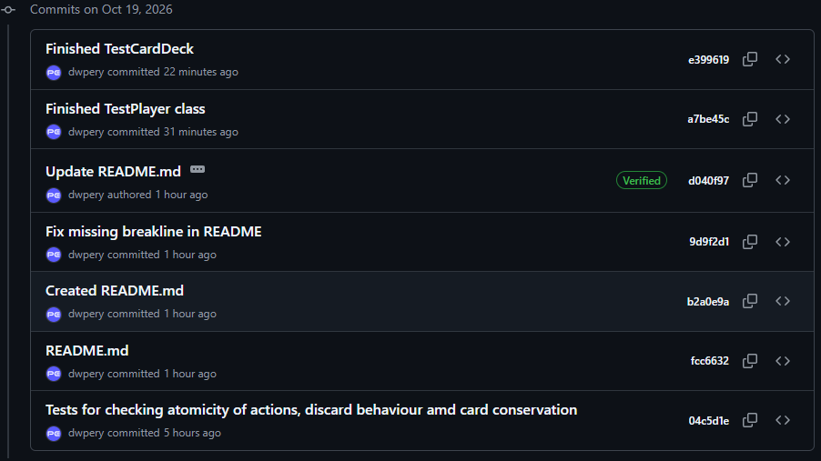
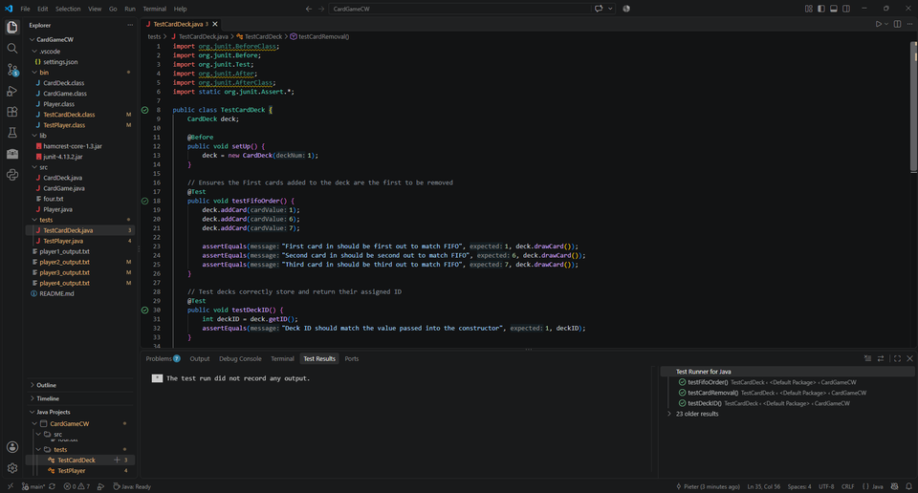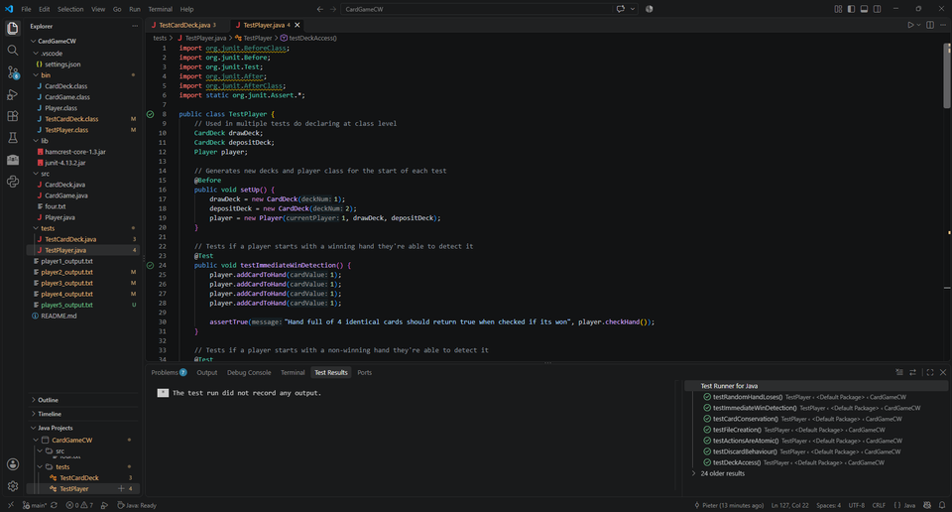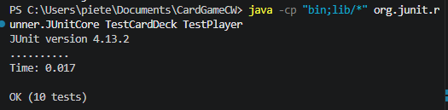
Development Process and Pair Programming Record
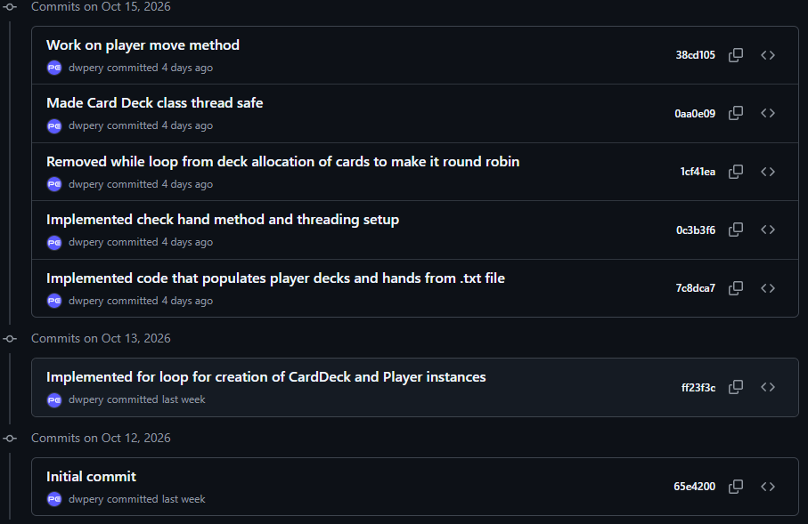
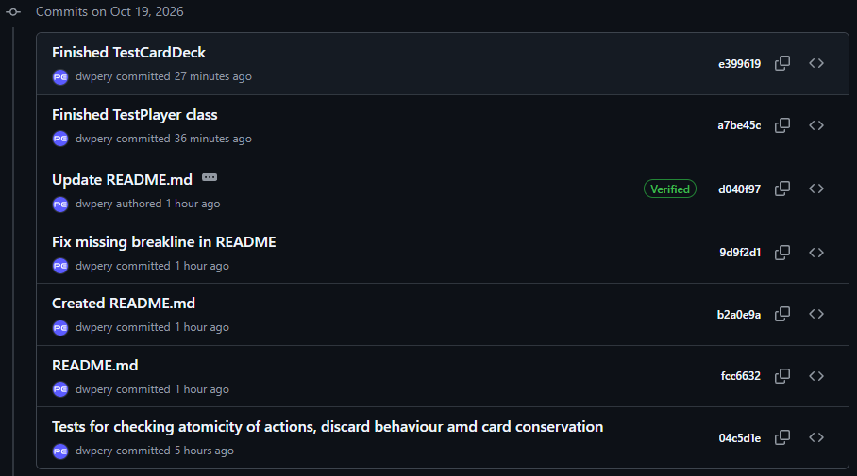
The project was developed over multiple sessions on a single laptop. We each took turns as driver and navigator each session, ensuring that we had equal roles. This is reflected in the Git commits shown below. The dates of the sessions are shown below, they were each carried out after lectures for 1-2 hours.

